CSA-1557 CLOUD COMPUTING LAB PRACTICAL

1.Create a simple cloud software application for Flight Reservation System using any Cloud Service Provider to demonstrate SaaS include the necessary fields

such as one way, round trip, From, to, Departure, Departure, Travelers & Class, Fare Type, International and Domestic Flights etc.

STEP-1:

Login into zoho.com and create an account.Then go to zoho creator and create a new application starting with a new form.Add or insert the required fields.

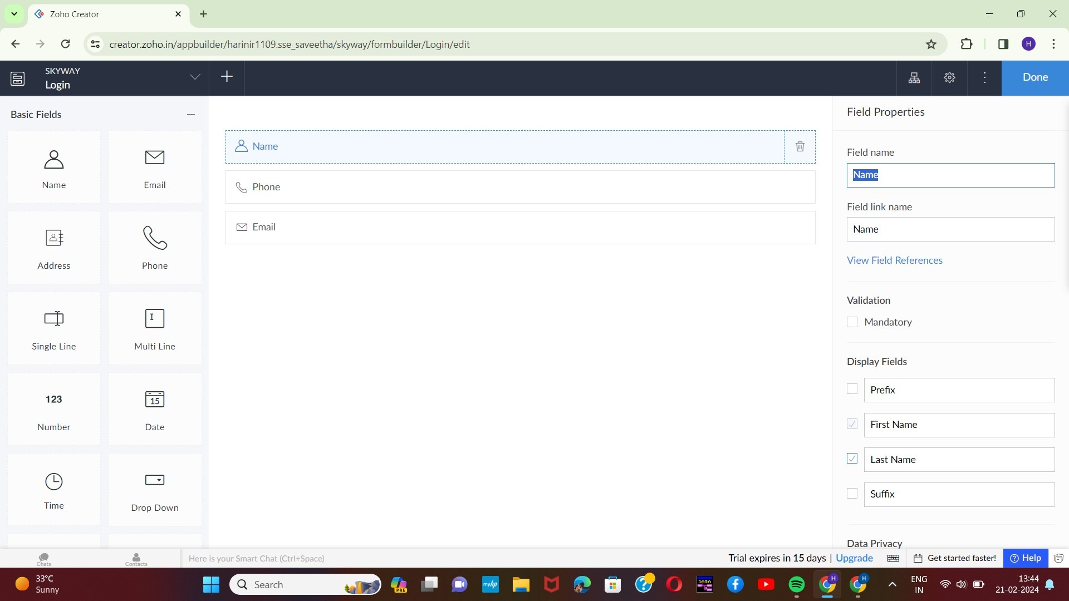

STEP-2:

After adding the fields go to the design page and view the alignment of the created

form.

1

2

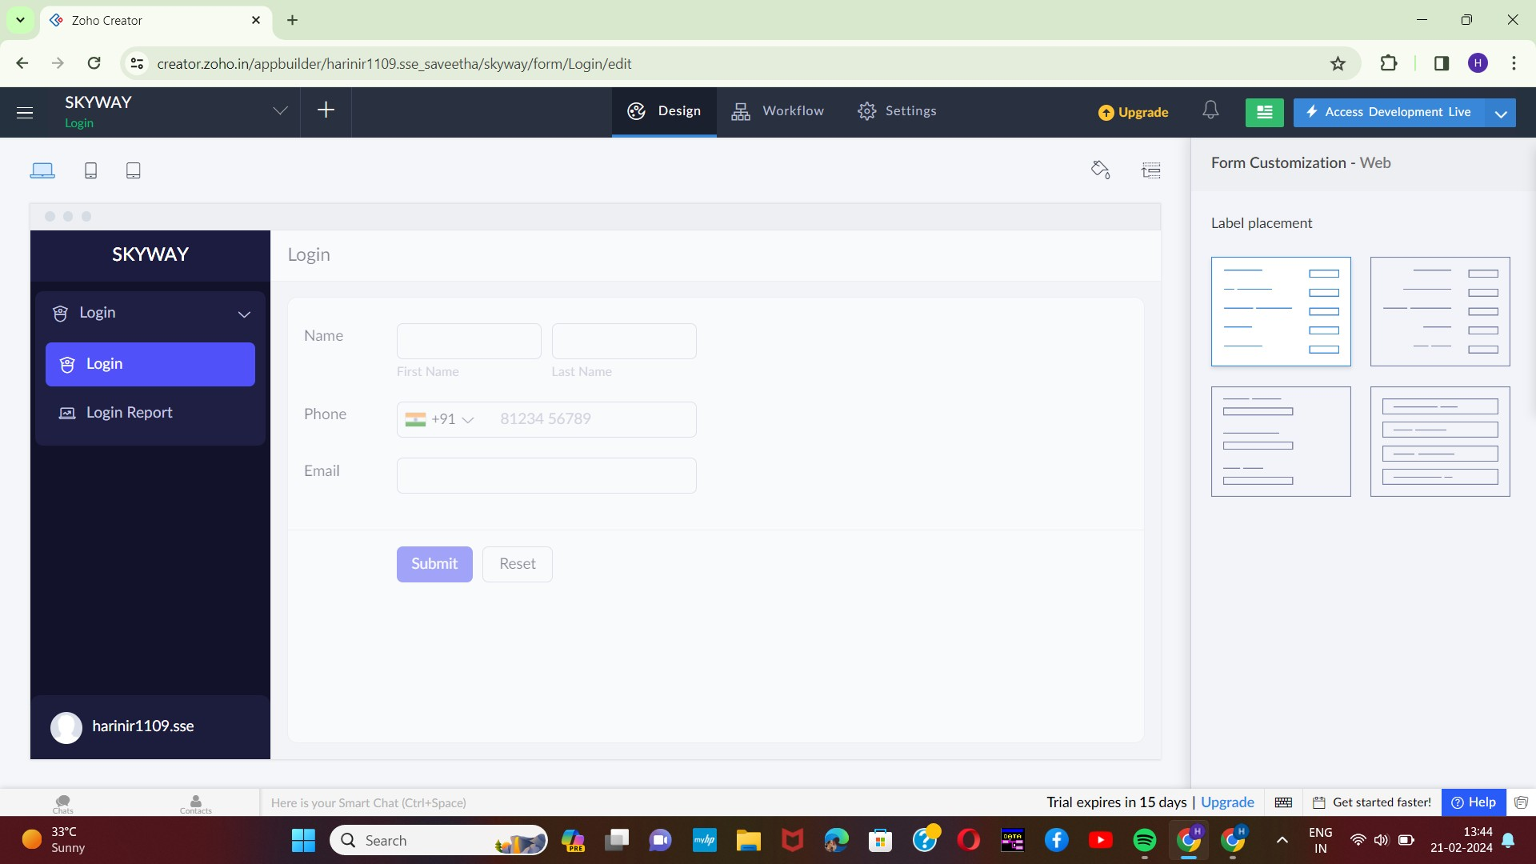

STEP-3:

Execute or run the model and get the required login form in live.

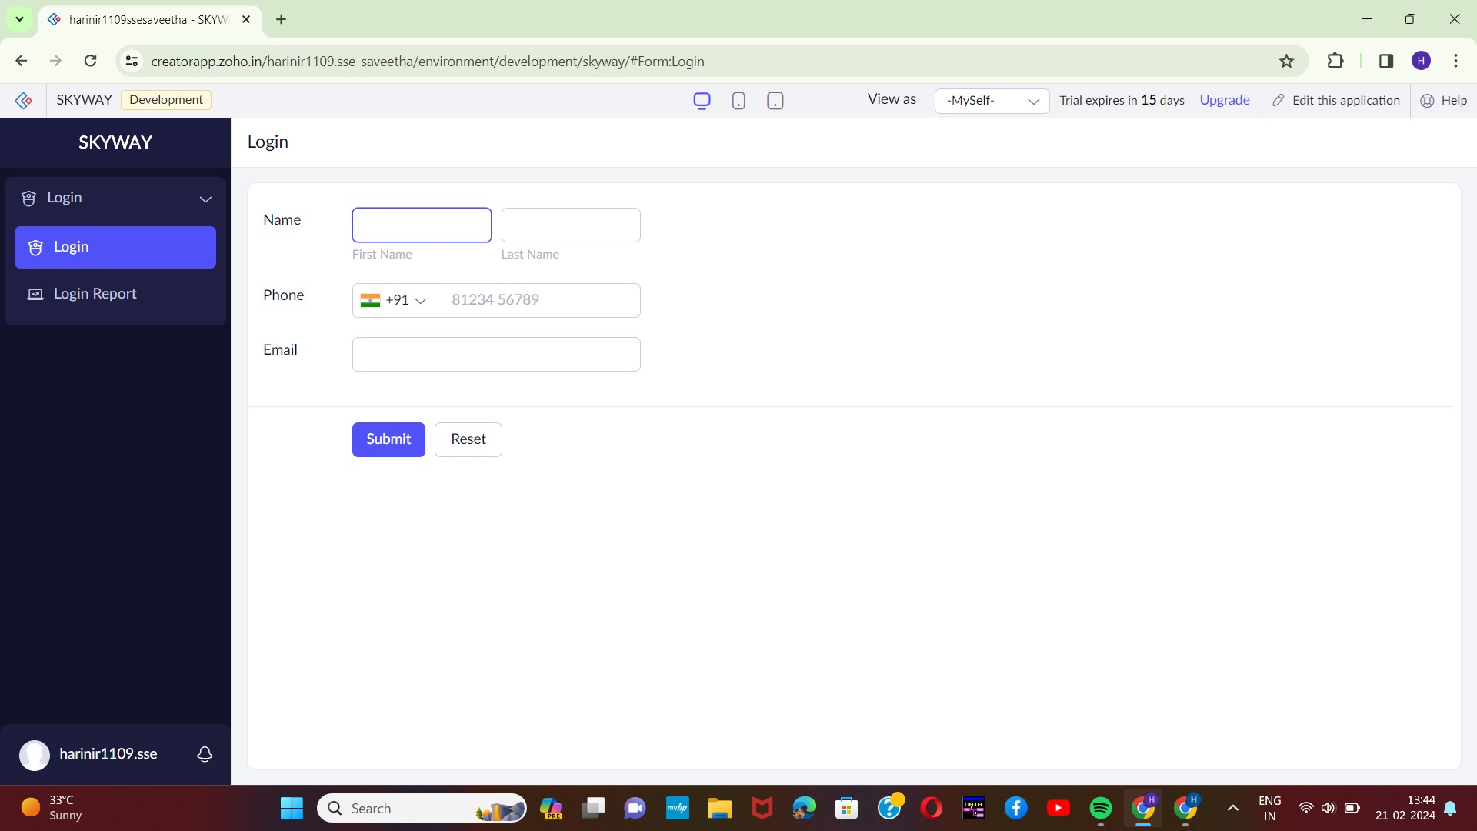

STEP-4:

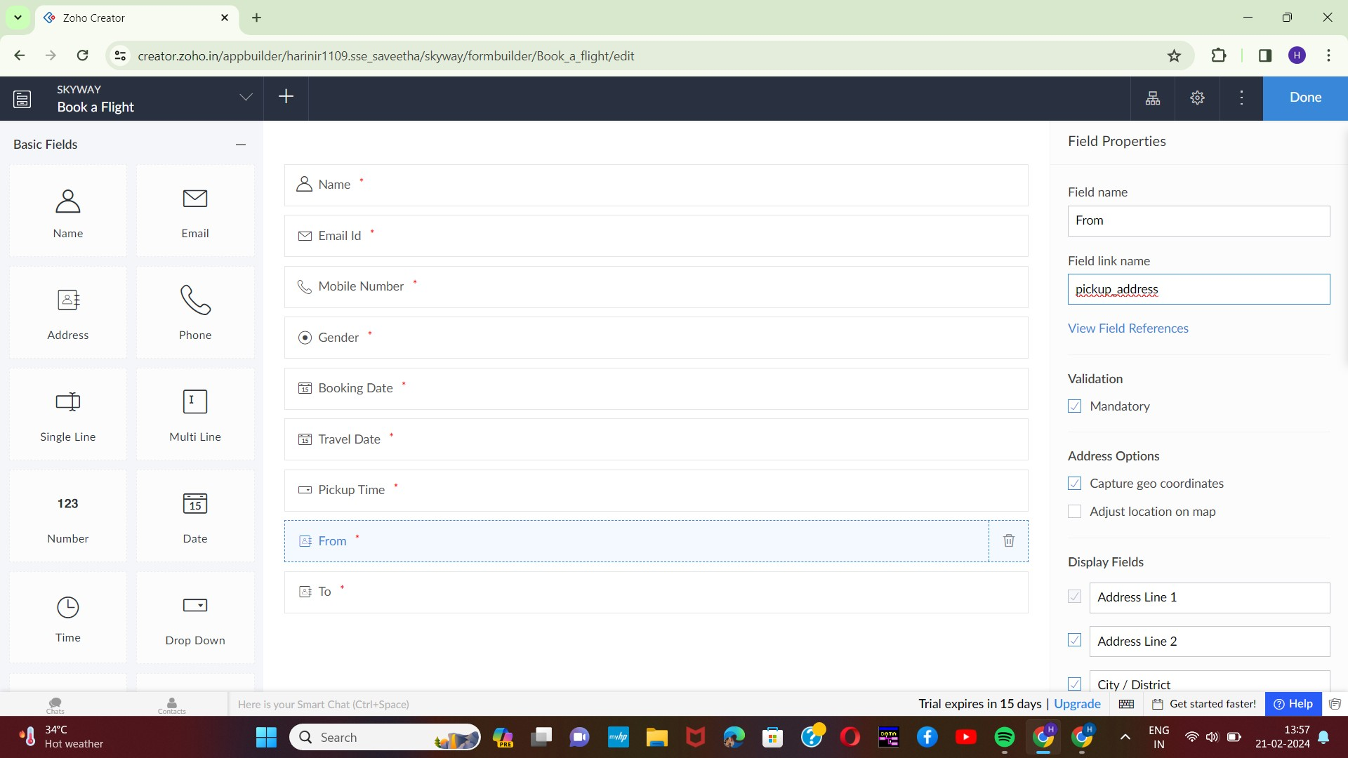Next step is to add another form which consists of booking details with the fields.

STEP-5:

After adding the fields go to the design page and view the alignment of the created

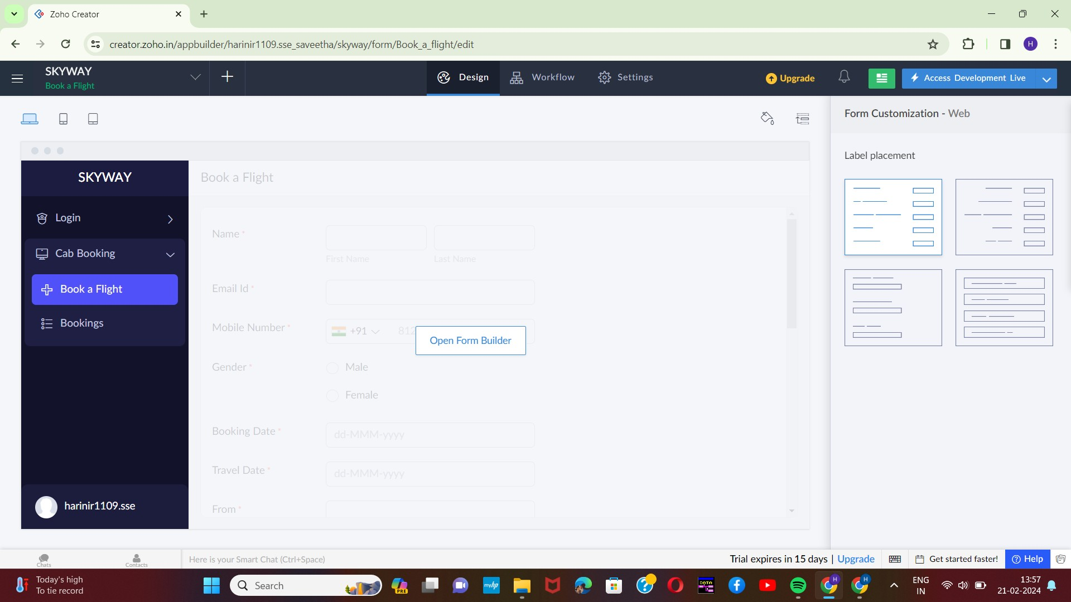form.

STEP-6:

Execute or run3 the model and get the required booking form live.

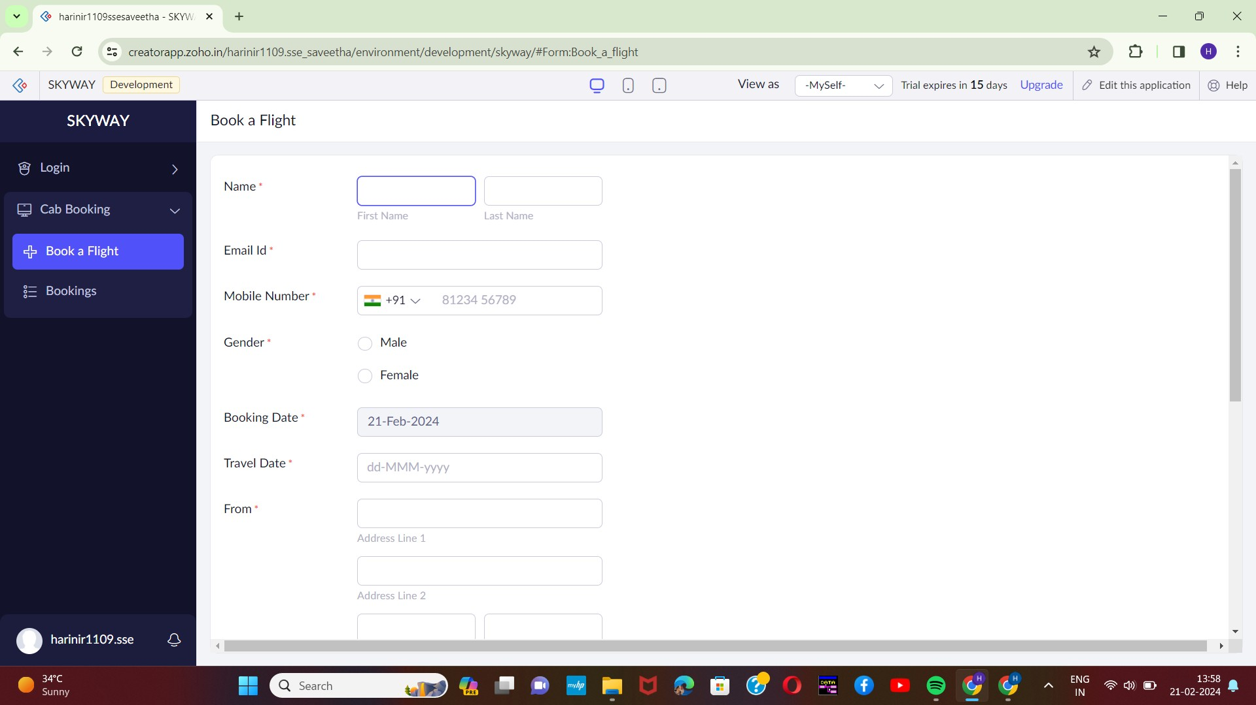

STEP-7:

Next step is to add another form which consists of selection of seats with the fields.

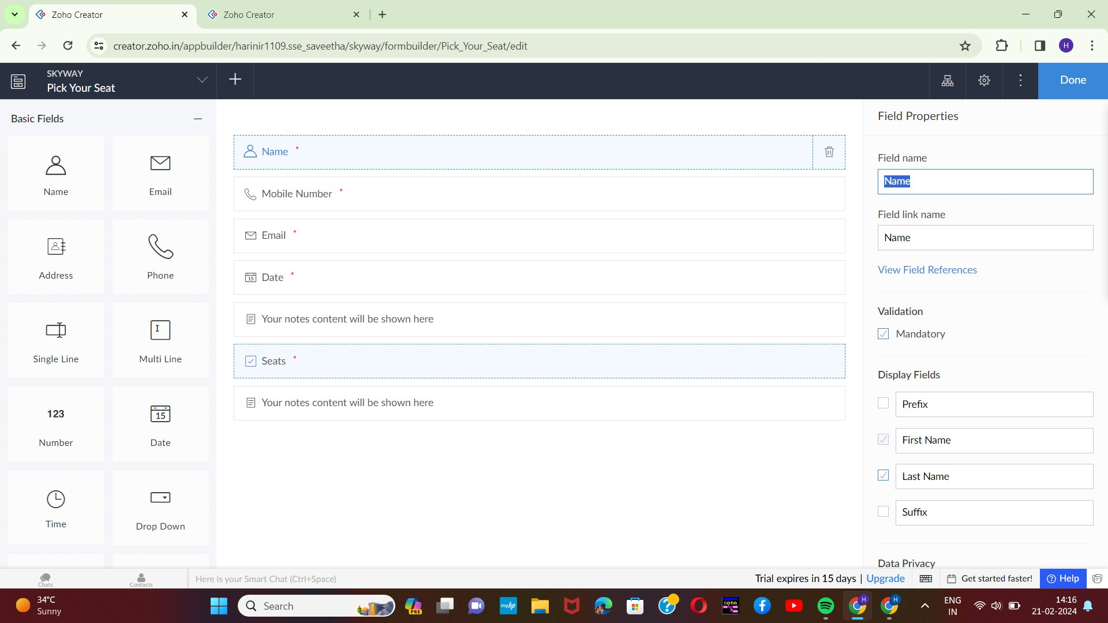

4

STEP-8:

form.

After adding the fields go to the design page and view the alignment of the created

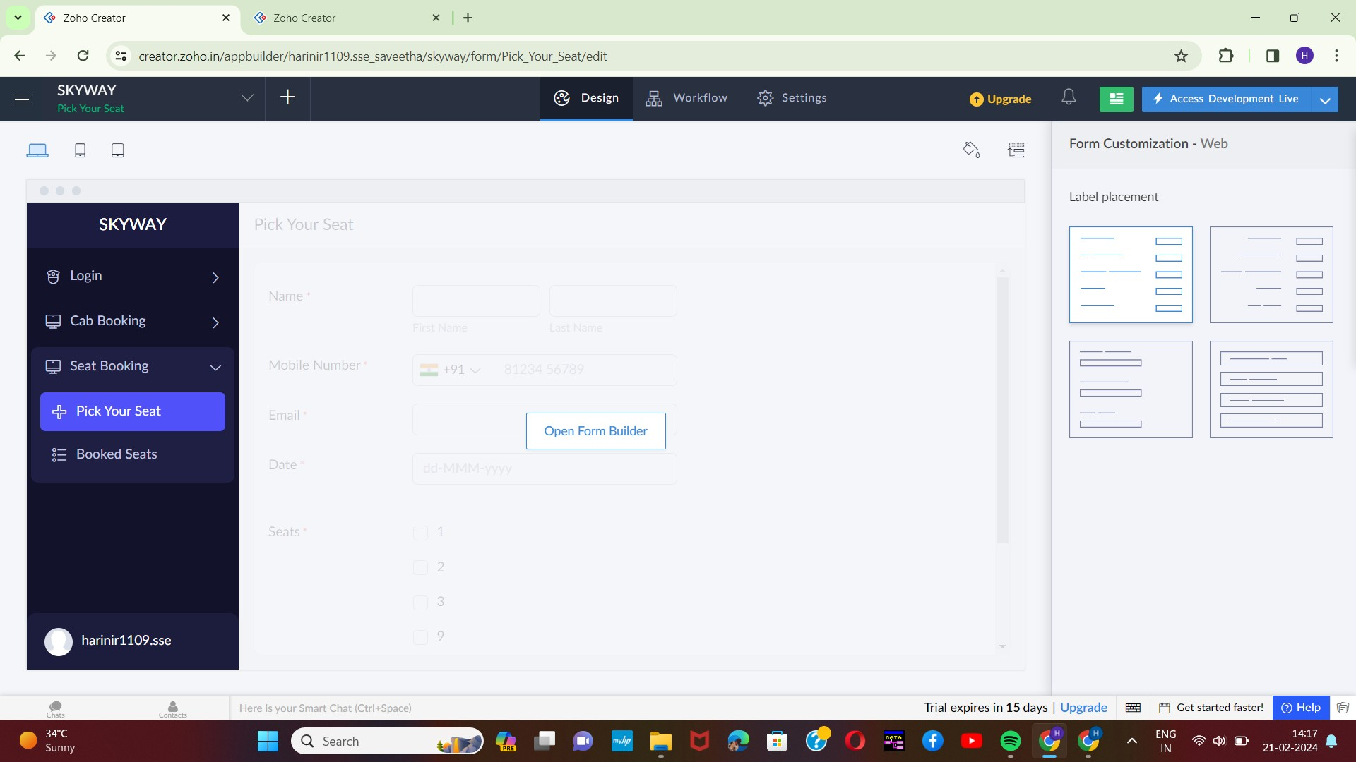

STEP-9:

Execute or run the model and get the required seat selecting from5 live.

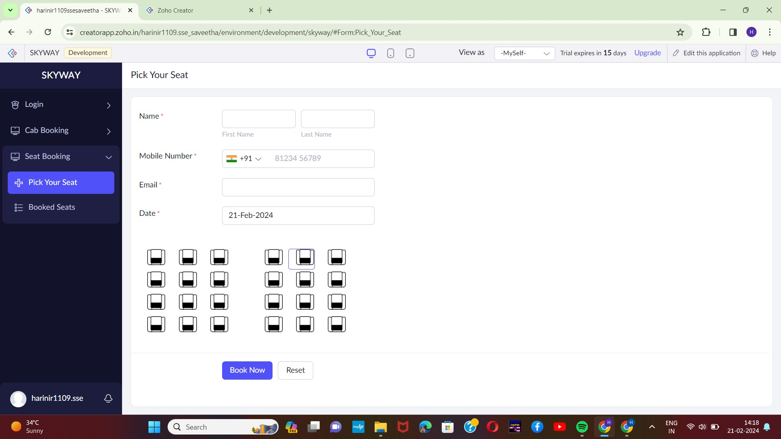

STEP-10:

Next step is to add another form which consists of contact details.

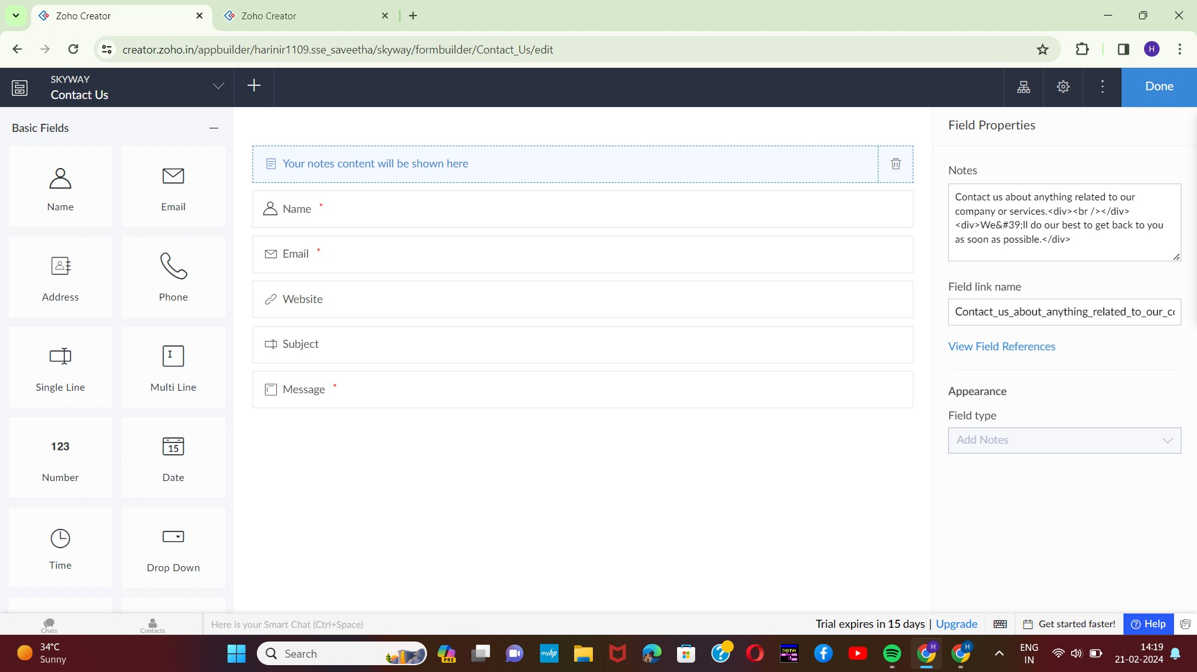

6

STEP-11:

The last step is to run and execute the contact details form and end the program.